Toyota Manufacturing North America
TTS – Tool Tracking System
Quick Reference guide
Unique Site Solutions (USS)
11-14-2018

Table of Contents
1.0 Enhancement Revisions 3
2.0 Introduction 4
3.0 Business Process Flow 5
4.0 How to request access for TTS 6
5.0 Login 7
6.0 Admin 8
6.1 How to add and delete team members/viewers 8
6.2 How to “Manage Master Data” 9
6.2.1 How to add, edit and delete - Category 10
6.2.2 How to add, edit and delete - Line 11
6.2.3 How to add, edit and delete - Shift 12
6.2.4 How to add, edit and delete - Add Problem 13
6.2.5 How to add, edit and delete - Tool Failure Type 14
6.2.6 How to add and delete - Add Tool Filter 15
7.0 Home 16
7.1 How to select Tool Settings 16
7.2 How to make changes to Tool Settings 16
7.3 How to edit or delete Tool Settings 17
7.4 How to create Tool Failure from Tool Setting 17
8.0 Create TFR 18
9.0 Search 19
9.1 Tool Point Management 19
9.2 Tool Failure Report 20

Enhancement Revisions

Test Track | Description | Author | Date | Version
1.0 | Draft | Sahiti Yarlagadda | 11/13/2018 | 0.0.01
1.0 | Draft – Process Diagram | Sahiti Yarlagadda | 11/15/2018 | 0.0.02
1.0 | Screen Elements | Sahiti Yarlagadda | 11/19/2018 | 0.0.03

Introduction

TTS application replaced TPM that resides on end of life hardware and OS. TPM app was developed for TMMK to enter and save tool failure reports. Now TTS application is developed for TMMK, TMMAL, TMMWV where TMs enter tool data and save it for future use. TMs create tool failure report for their line and Group Leaders receive notification to review and submit the TFR. System notifies tool regrind group who will further review the TFR and completes it. Also, TM can map Maximo line data with plant line data, set-up tool setup error, tool failure type, category and problems. Business can build Power BI Reports based on this data.
This application has four roles and their description is as follows:
Admin – This user has control of the whole application
Team Member – Viewer – This user creates Tool Setting, Tool Change and Tool Failure
Group Leader – Editor – This user reviews the TFR and submits for completion
Tool Regrind Group - Reviewer – This user can create and complete TFR

Business Process Flow

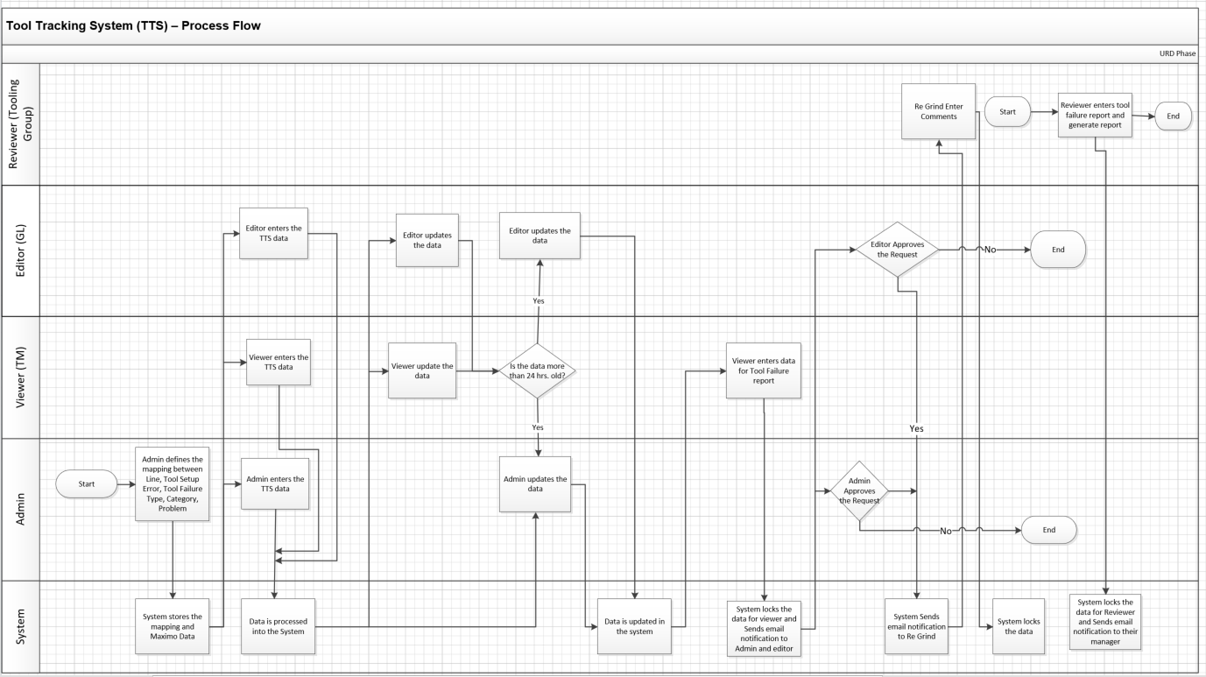

How to request access for TTS
- Team Members – Reach out to your NAMC TTS Admin

Site | Team Member | Email ID
TMMK | Kim Raney | kimberely.raney@toyota.com
 | Bruce Steele | bruce.steele.jr@toyota.com
TMMAL | Adam Smart | adam.smart@toyota.com
 | Jason King | jason.king@toyota.com
 | Ronnie Holt | ronnie.holt@toyota.com
 | Spencer Miller | spencer.miller@toyota.com
 | Ray A Gosberry | ray.gosberryjr@toyota.com

- Group Leaders, Tool Regrind Group and Admins – Open 1TS request
- How to request access on 1TS - https://tmna.service-now.com/1ts/
    - Click on “Make a Request” - > “Application Services” -> “USS applications”
    - Select “TTS” and fill the form

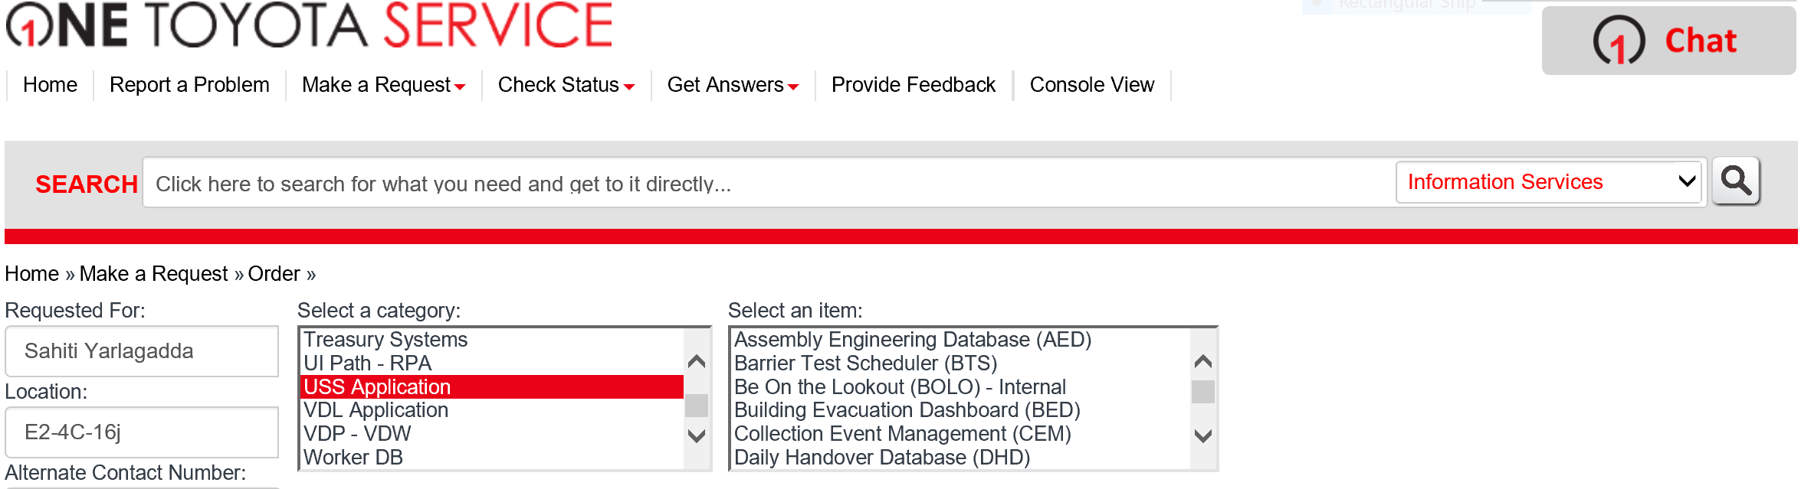

Login

- Team Members – Select NAMC, enter Workday ID and click on “Set” button

- Group Leaders, Tool Regrind Group and Admins – Click on Login button and follow instructions

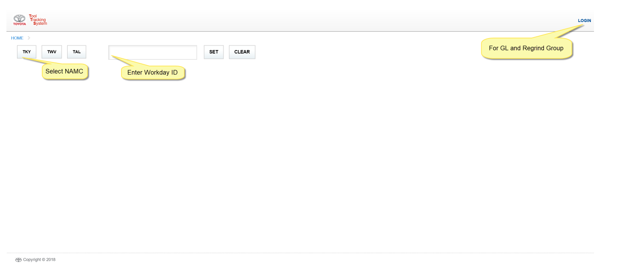

Admin

How to add and delete team members/viewers
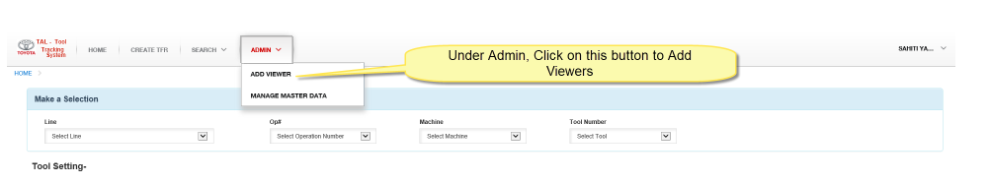

- Enter Team Member name and click on “Add New” button

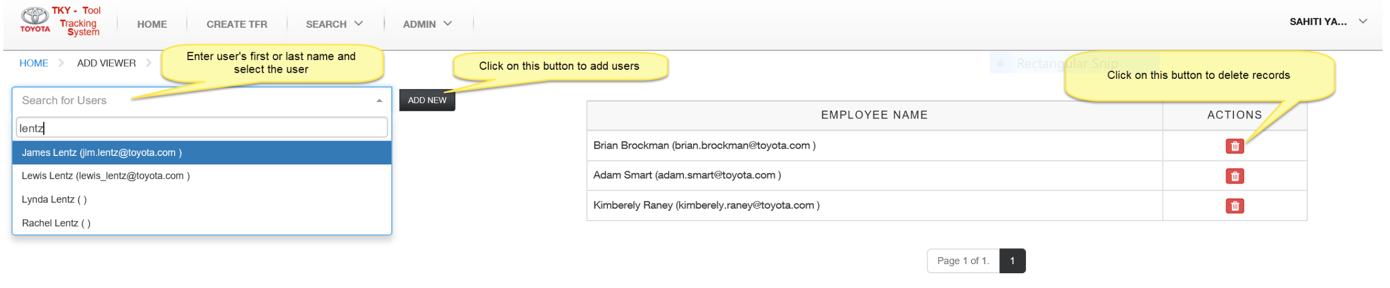

How to “Manage Master Data” - Admin

- Under Admin, click on “Manage Master Data”

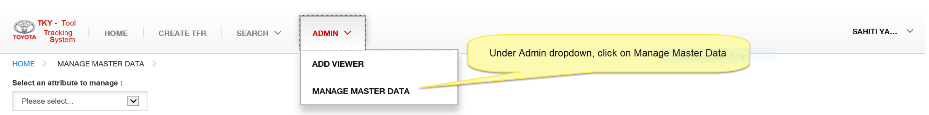

How to add, edit and delete - Category

    - Select “Category” from dropdown

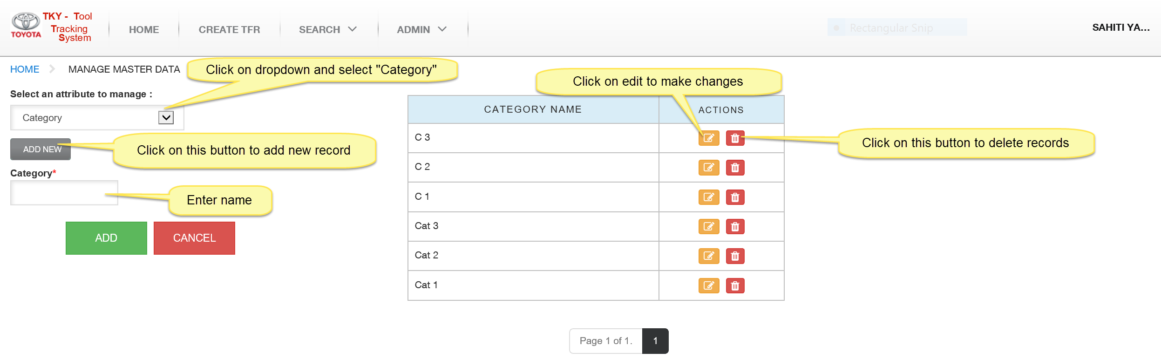

How to add, edit and delete - Line

    - Select “Line” from dropdown

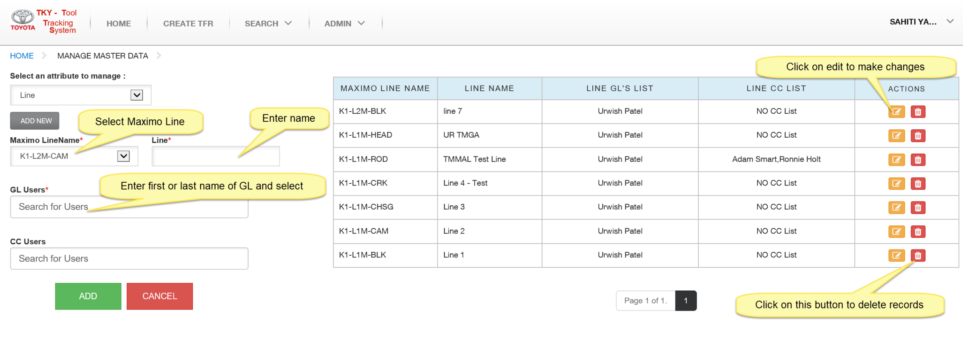

How to add, edit and delete - Shift

    - Select “Shift” from dropdown

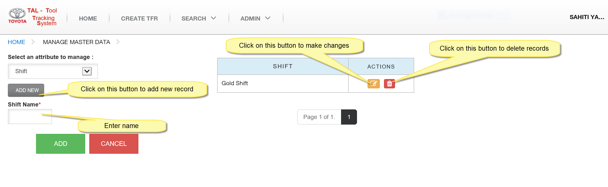

How to add, edit and delete - Add Problem

    - Select “Add Problem” from dropdown

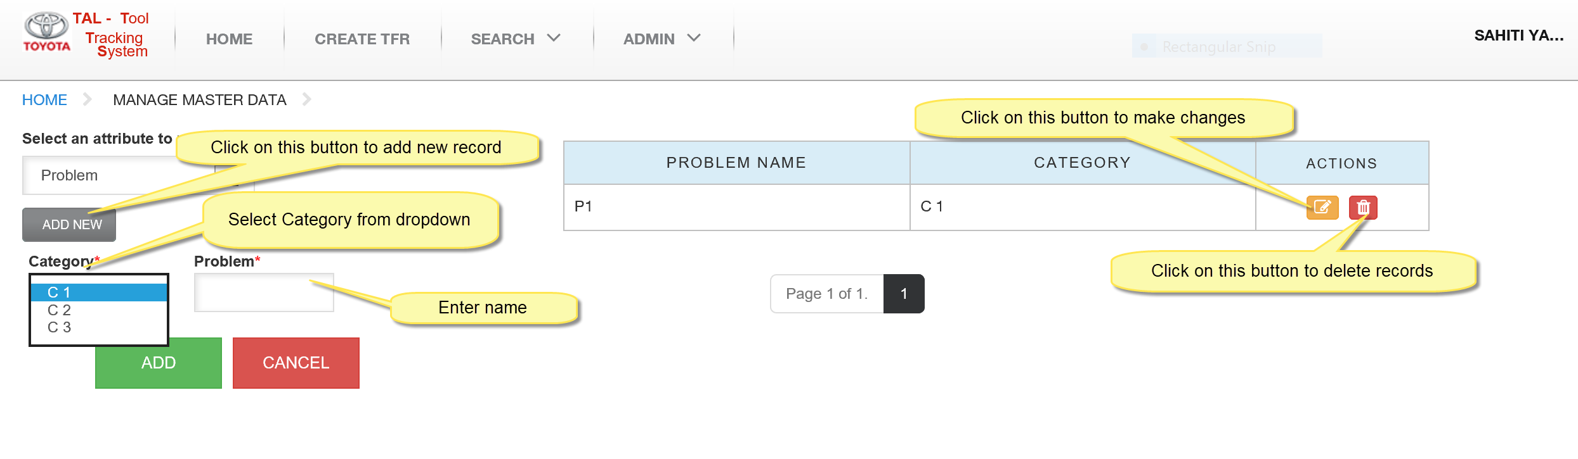

How to add, edit and delete - Tool Failure Type

    - Select “Add Tool Failure Type” from dropdown

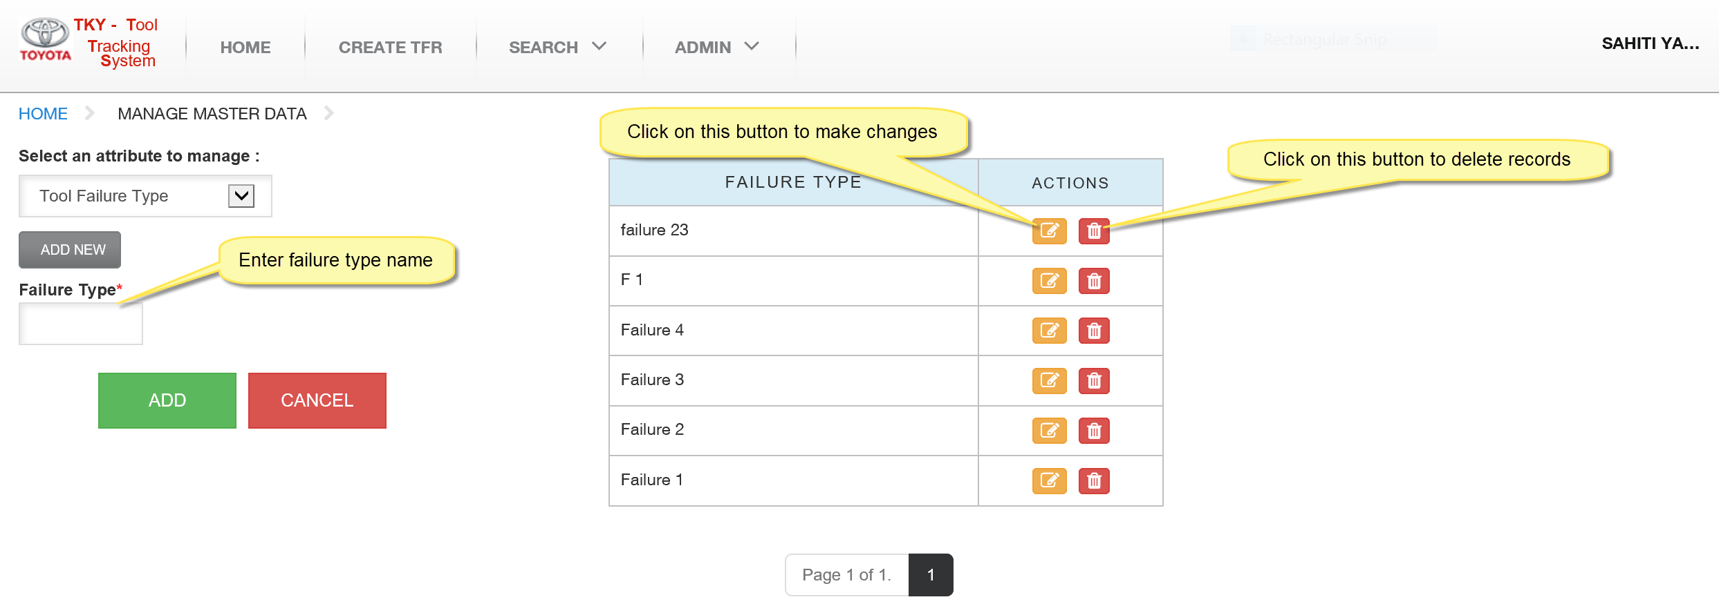

How to add and delete - Add Tool Filter

    - Select “Add Tool Filter” from dropdown

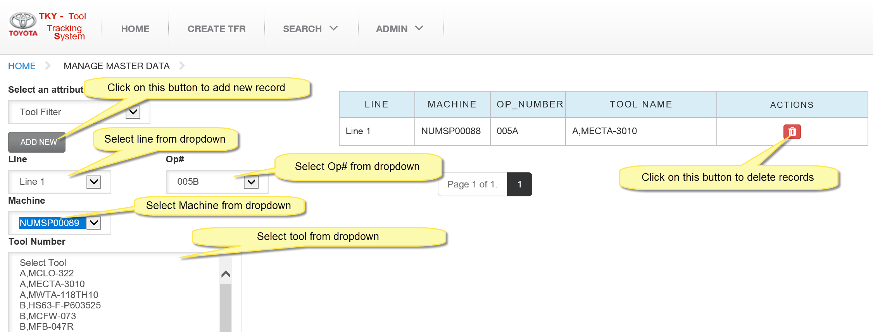

Home – All Users

How to select Tool Settings
- Select “Line, OP#, Machine, Tool Number” from dropdown and click on “Add New Button”
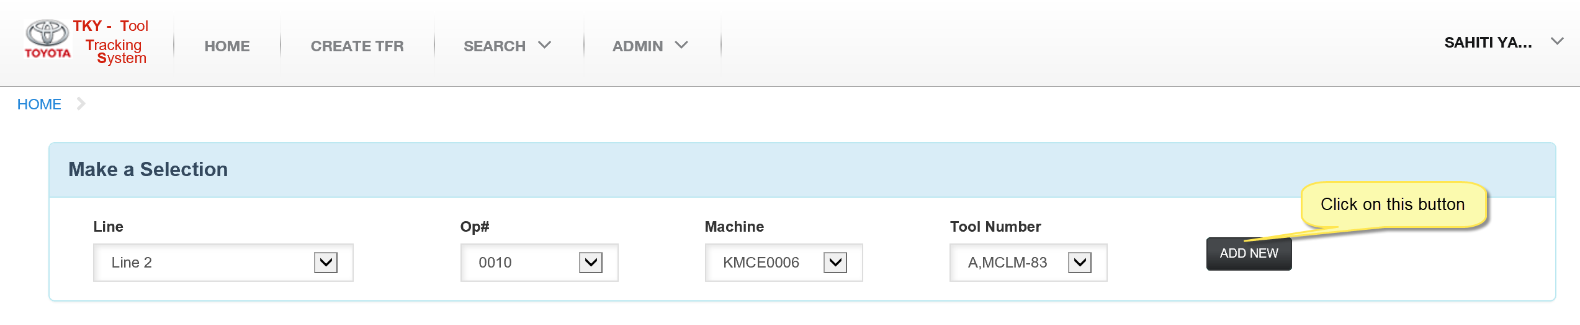

How to make changes to Tool Settings

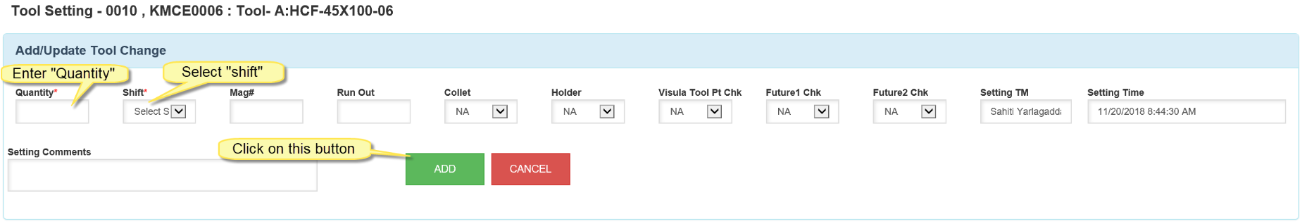

How to edit or delete Tool Settings

How to create Tool Failure from Tool Setting
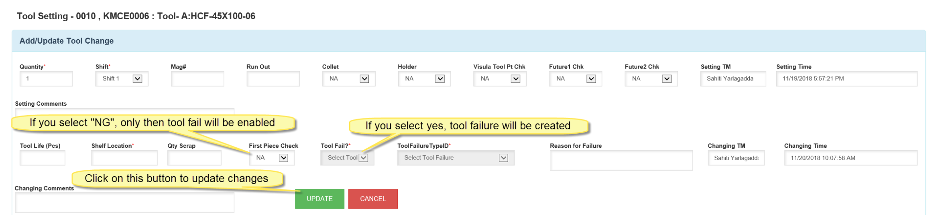

Create TFR
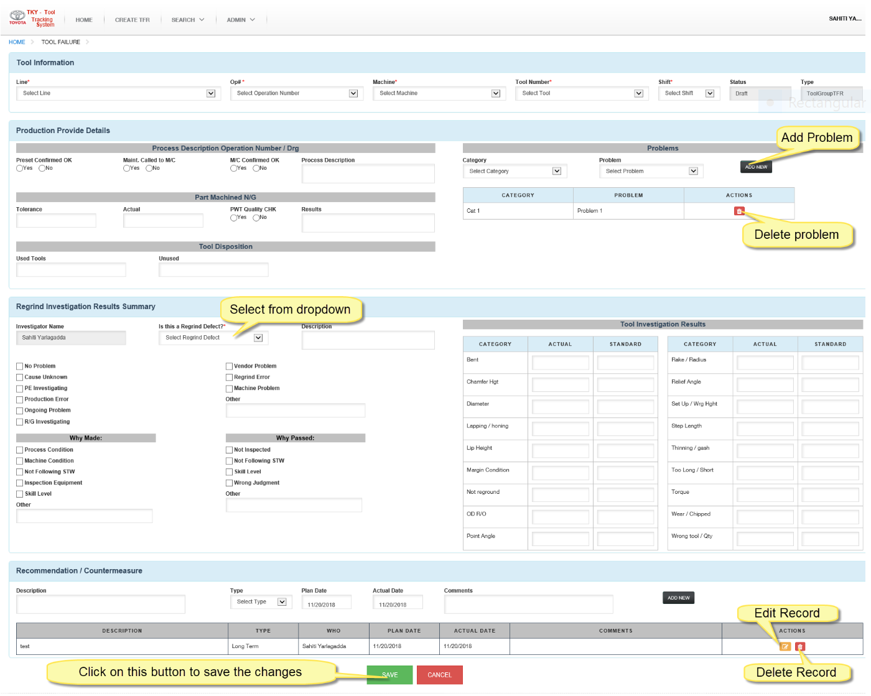

Search

Tool Point Management
    - Under “Search”, click on “Tool Point Management”
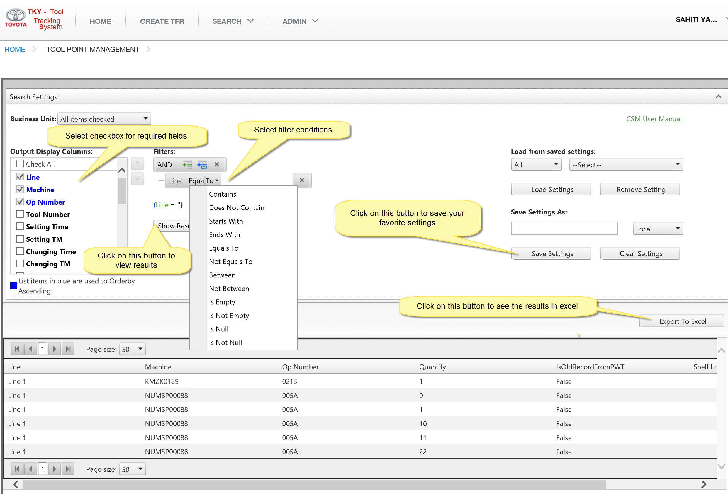

Tool Failure Report
    - Under “Search”, click on “Tool Failure Report”
